**Experiment No. 9**

**Title :** Implementation of Linear Search in C++

**Problem Statement :** Implementing Linear Search algorithm in C++

**Algorithm :**

**S1 :** Start

**S2 :** Declare an array and loop control variables.

**S3 :** Ask for the array input and element to be searched from user.

**S4 :** with the for loop check if element in an array is equal to one searching.

**S5 :** If it is equal the print position of element else print element not found.

**S6 :** Stop

**Code :**

//Linear Search

#include<iostream>

using namespace std;

int main()

{

int arr[20],n,x,i,flag=0;

cout<<"How many elements?";

cin>>n;

cout<<"\nEnter elements of the array\n";

for(i=0;i<n;++i)

cin>>arr[i];

cout<<"\nEnter element to search:";

cin>>x;

for(i=0;i<n;++i)

{ if(arr[i]==x)

{ flag=1;

break;

}

}

if(flag)

cout<<"\nElement is found at position "<<i+1;

else

cout<<"\nElement not found";

return 0;

}

**Output :** 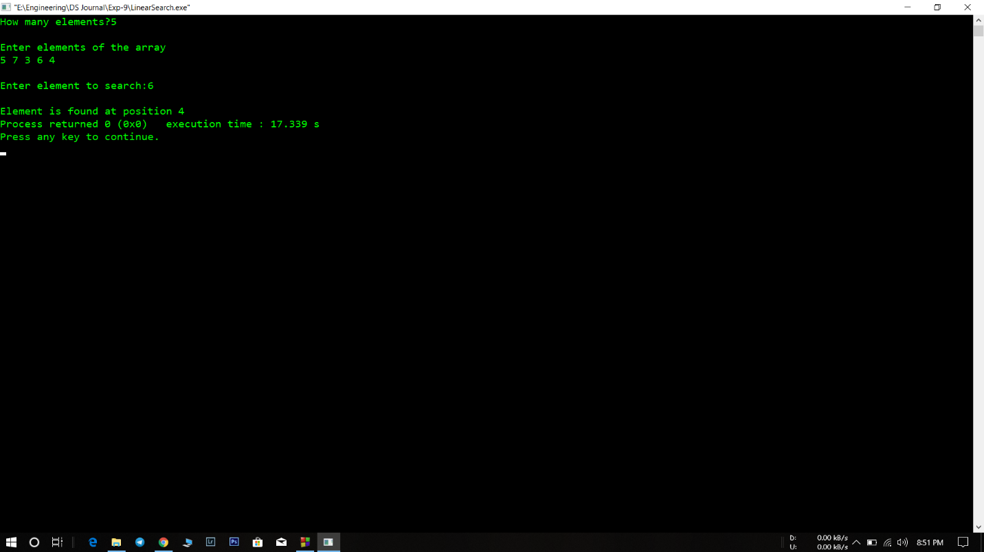

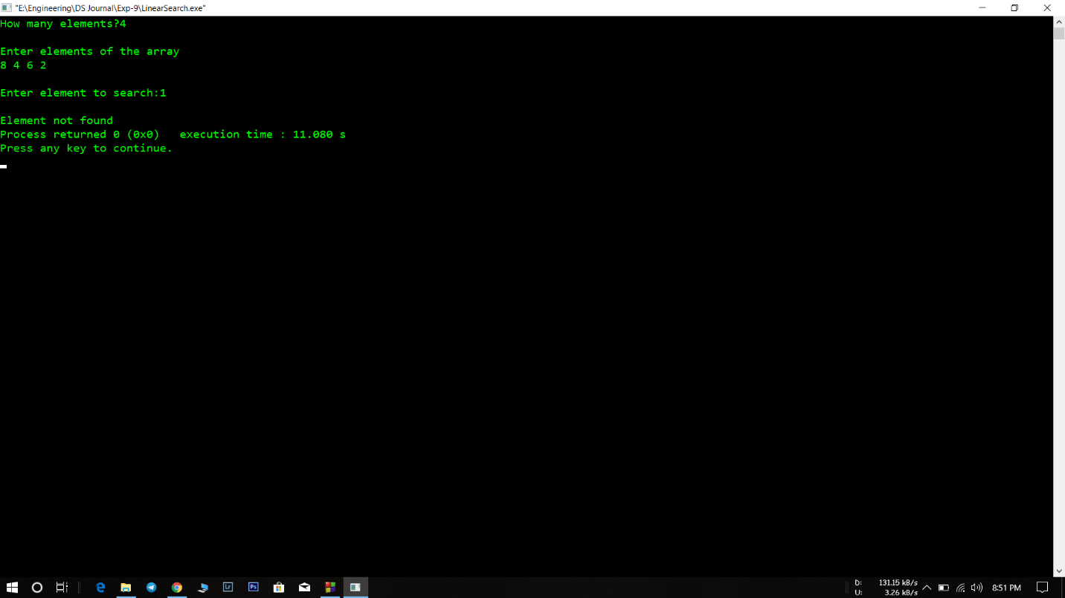

**Analysis :**

* The linear search is a long process for an array with many elements and key searched is the last element then it time complexity becomes an issue.
* The program returns only the first occurrence of the key element to be searched.